PIZZA SALES SQL QUERIES

create database pizzas;

use pizzas;

select * from pizzas.pizza_sales;

---- Total Revenue

SELECT SUM(total_price) AS Total_Revenue FROM pizza_sales;

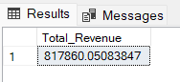

--- Average Order Value

SELECT (SUM(total_price) / COUNT(DISTINCT order_id)) AS Avg_order_Value FROM pizza_sales;

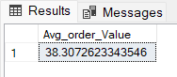

---- Total Pizzas Sold

SELECT SUM(quantity) AS Total_pizza_sold FROM pizza_sales;

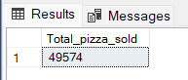

---- Total Orders

SELECT COUNT(DISTINCT order_id) AS Total_Orders FROM pizza_sales;

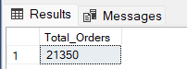

----- Average Pizzas Per Order

SELECT CAST(CAST(SUM(quantity) AS DECIMAL(10,2)) /

CAST(COUNT(DISTINCT order_id) AS DECIMAL(10,2)) AS DECIMAL(10,2))

AS Avg_Pizzas_per_order

FROM pizza_sales;

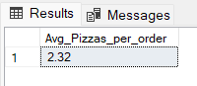

------ % of Sales by Pizza Category

SELECT pizza_category, CAST(SUM(total_price) AS DECIMAL(10,2)) as total_revenue,

CAST(SUM(total_price) * 100 / (SELECT SUM(total_price) from pizza_sales) AS DECIMAL(10,2)) AS PCT

FROM pizza_sales

GROUP BY pizza_category;

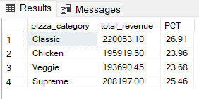

----- % of Sales by Pizza Size

SELECT pizza_size, CAST(SUM(total_price) AS DECIMAL(10,2)) as total_revenue,

CAST(SUM(total_price) * 100 / (SELECT SUM(total_price) from pizza_sales) AS DECIMAL(10,2)) AS PCT

FROM pizza_sales

GROUP BY pizza_size

ORDER BY pizza_size;

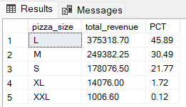

----- Total Pizzas Sold by Pizza Category

SELECT pizza_category, SUM(quantity) as Total_Quantity_Sold

FROM pizza_sales

GROUP BY pizza_category

ORDER BY Total_Quantity_Sold DESC;

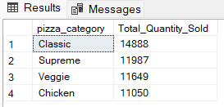

---- Top 5 Best Sellers by Total Pizzas Sold

SELECT pizza_name, SUM(quantity) AS Total_Pizza_Sold

FROM pizza_sales

GROUP BY pizza_name

ORDER BY Total_Pizza_Sold DESC limit 5;

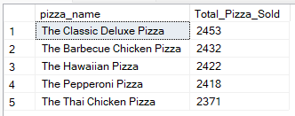

----- Bottom 5 Best Sellers by Total Pizzas Sold

SELECT pizza_name, SUM(quantity) AS Total_Pizza_Sold

FROM pizza_sales

GROUP BY pizza_name

ORDER BY Total_Pizza_Sold ASC limit 5;

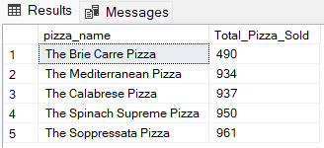

------ Daily Trend for Total Orders

SELECT datename(DW, order_date) AS order_day, COUNT(DISTINCT order_id) AS total_orders

FROM pizza_sales

GROUP BY datename(DW, order_date);

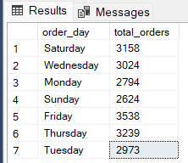

----- Hourly Trend for Orders

SELECT DATEPART(HOUR, order_time) as order_hours, COUNT(DISTINCT order_id) as total_orders

from pizza_sales

group by DATEPART(HOUR, order_time)

order by DATEPART(HOUR, order_time);

